1. **Experiment:** Molecular dynamics simulation
2. **Time:** 2025.05.10-2025.05.29
3. **Member:** Xudong Tang, Yang Jin, Kaiqing Zhang, Binxuan Zhang, Xuantong Liu
4. **Materials:**

(1) Software: GROMACS 2022.5, Alphafold3, HADDOCK, Visual Molecular Dynamics (VMD)

(2) Database: Protein Data Bank (PDB)

(3) Force Fields: CHARMM36m, TIP3P, CHARMM

(4) Simulation Environment: Periodic Cubic Water Box, NaCl

1. **Method:**
2. System Preparation
3. The receptor structure is modeled based on the X-ray crystal structure (PDB ID: 2B5I). The designed protein's three-dimensional structure is predicted using AlphaFold3 and subjected to preliminary optimization.
4. Molecular docking is performed using HADDOCK software to obtain the initial binding structure of the receptor-protein complex. The structure with the lowest binding energy and optimal electrostatic interactions is selected as the initial conformation for subsequent molecular dynamics simulations.
5. The complex is placed in a periodic cubic water box, ensuring a minimum distance of 12 Å between any protein atom and the box boundary to provide sufficient solvation. The solvent environment is constructed using the TIP3P water model, with Na+ and Cl- ions added to neutralize the system and simulate physiological salt concentration.
6. The protein is parameterized using the CHARMM36m force field, the water molecules use the TIP3P model, and ion parameters are derived from the CHARMM force field.
7. Molecular Dynamics Simulation Settings

All molecular dynamics simulations are performed using the GROMACS 2022.5 software package.

1. Energy minimization is conducted using the steepest descent algorithm to eliminate unfavorable atomic contacts and geometric clashes. The minimization is set to a maximum of 50,000 steps, with a convergence criterion of the maximum force being less than 1000 kJ/mol/nm.
2. In the first phase of equilibration (canonical ensemble, NVT), the system is equilibrated for 1 ns at a temperature of 300 K, controlled using the velocity-rescaling thermostat. Positional restraints with a force constant of 1000 kJ/mol/nm² are applied to the protein backbone, allowing relaxation of the side chains and solvent molecules.
3. In the second phase (constant-pressure, constant-temperature system, NPT), the system is equilibrated for 4 ns at 300 K and 1 bar, with pressure controlled using the Berendsen pressure coupling method. During this phase, positional restraints on the solute are gradually reduced from 1000 kJ/mol/nm² to 0 kJ/mol/nm². A time step of 1 fs is used, with all bonds constrained using the LINCS algorithm.
4. The production simulation is conducted in the NPT ensemble for 50 ns with a time step of 2 fs. The temperature is maintained at 300 K using the velocity-rescaling thermostat, and the pressure is controlled at 1 bar using the Parrinello-Rahman pressure coupling method. Short-range interactions, including van der Waals and electrostatic forces, are calculated with a cutoff distance of 1.2 nm, while long-range electrostatics are computed using the particle mesh Ewald (PME) method with a grid spacing of 0.16 nm and fourth-order interpolation. System coordinates are saved every 10 ps for subsequent analysis.
5. Data Analysis
6. GROMACS tools are used to analyze trajectory data, including calculations of root mean square deviation (RMSD), root mean square fluctuation (RMSF), and interaction changes at the binding interface residues.
7. Visual Molecular Dynamics (VMD) software is employed to visualize trajectories and extract snapshots for comparing the initial and final binding modes.
8. Fluctuations in van der Waals and electrostatic interactions are calculated and presented in radar charts to visually compare the binding performance of different complexes. B-factor analysis is integrated to evaluate the structural stability and residue fluctuations of the complex.
9. The initial and final binding interfaces are compared to analyze changes in key residue interactions.
10. **Result:**

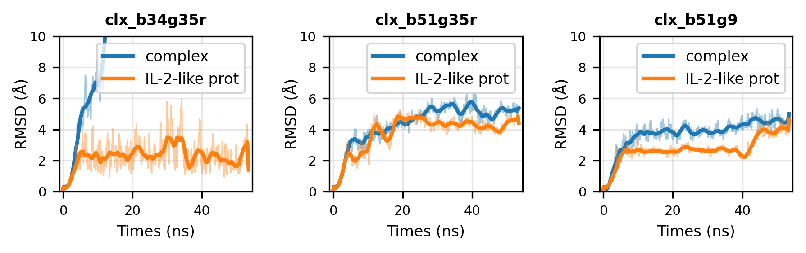

**Fig.1** RMSD Trends of three IL-2 mimics and IL-2R-mimic complexes

Molecular dynamics simulations of IL-2 mimic and its complex with IL-2 receptor βγ. Three different sequences (clx_b34g35r, clx_b51g35r, clx_b51g9) were analyzed. The blue curves represent the RMSD changes of the IL-2 mimic in complex with IL-2Rβγ, while the orange curves show the RMSD changes of the IL-2 mimic alone. The x-axis indicates simulation time (ns), and the y-axis represents RMSD values (Å). The results demonstrate that both B51G35R and B51G9 exhibit stable binding to IL-2Rβγ, whereas B34G35R shows a significant increase in RMSD values, indicating poor or no binding to the receptor.

In MD simulations, we found that the RMSD value of the B34G35R complex was relatively high, indicating that its binding mode with the receptor could not be maintained. In contrast, the RMSD values of the B51G35R and B51G9 complexes were lower, demonstrating better stability. However, results from wet experiments (OCTET) showed that B34G35R had the highest affinity for the receptor. This contradiction may be attributed to the following three reasons:

First, although the simulation time was sufficient to observe the stability of most complexes, the binding mode of B34G35R might require a longer time to stabilize. Short-term conformational changes may not fully reflect its true binding state. Second, the initial structure of B34G5R obtained through HADDOCK docking was predicted by AlphaFold3, which may not accurately represent its true conformation in the receptor-bound state, leading to the loss of its binding mode during the MD simulation. Lastly, MD simulations did not account for entropy effects and more complex solvent environments, which might play a critical role in the high affinity of B34G35R observed in wet experiments.

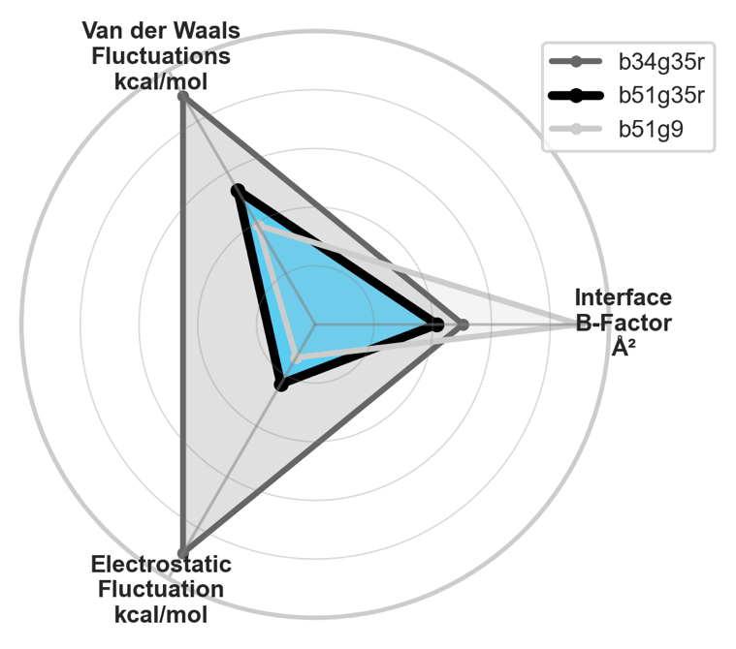

**Fig.2** Energy and Fluctuation Analysis Legend

Radar plot comparing the Van der Waals fluctuations (kcal/mol), electrostatic fluctuations (kcal/mol), and interface B-factor (Å²) for three IL-2 mimic sequences (B34G35R, B51G35r, and B51G9). The Van der Waals and electrostatic fluctuations represent the stability of the IL-2 mimic in complex with IL-2Rβγ, while the interface B-factor reflects the structural flexibility of the IL-2 mimic itself. The data indicate that B51G35R and B51G9 exhibit lower fluctuations in both Van der Waals and electrostatic interactions, suggesting stable binding to IL-2Rβγ. In contrast, B34G35R shows higher fluctuations, indicating weaker or unstable binding. Additionally, the interface B-factor highlights differences in mimic flexibility across the sequences.

Additionally, radar charts showed the fluctuations in van der Waals forces, electrostatic interactions, and B-factors for different complexes. The van der Waals forces fluctuations and electrostatic fluctuations of B34G35R were both relatively high, but its interface B-factor were lower than those of B51G35R and b51g9. It is important to note that the calculation strategy for B-factors (e.g., alignment method, reference sequence selection) may influence the results. In this study, we used an alignment method based on the interface of the complexes and specifically analyzed the residue fluctuations in the interface region. The radar chart showed that B34G35R had relatively high van der Waals fluctuations and electrostatic fluctuations, which might indicate its strong binding ability to the receptor in the Octet experiment. However, MD simulations may not fully capture this synergistic effect. For example, B34G35R might achieve high affinity in wet experiments through dynamic conformational adjustments, whereas MD simulations, due to limitations in time and initial structure, failed to fully reveal its true dynamic binding process.